FRACTURED CUSP

Q What is a fractured cusp?

A This is a horizontal fracture in the cusp of the tooth, usually found on filled double teeth.

Q What are the symptoms?

A There will be pain when biting and chewing because the crack and pain will only be present when pressure is applied.

Q Why has the tooth cracked?

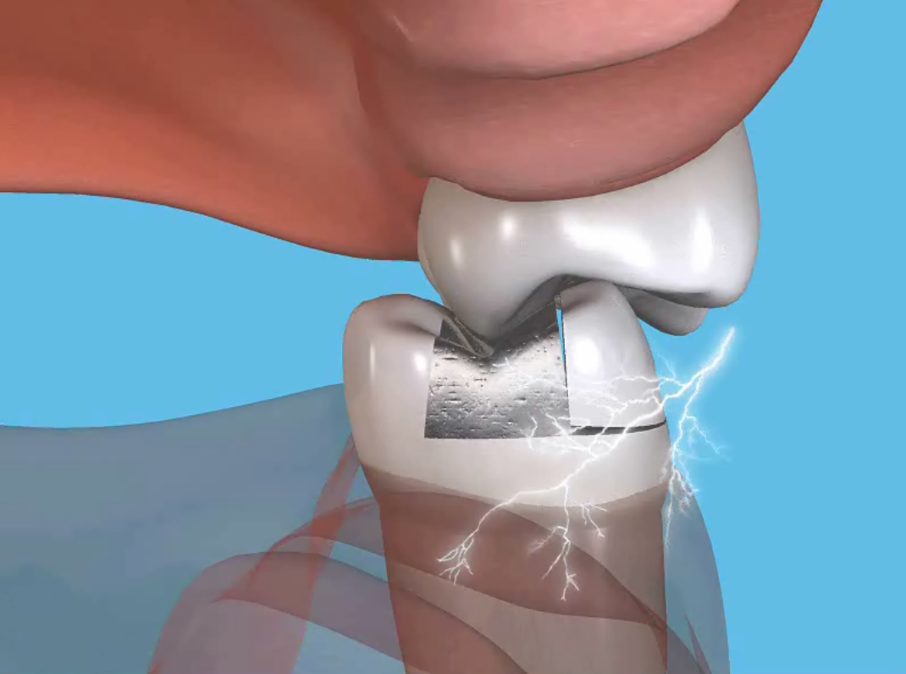
A Normally the pressure of biting and chewing will be spread across the whole width and surface of the tooth. When a tooth has been filled the natural width and surface area of the tooth has been reduced. The natural tooth will flex on pressure and with a filling present this smaller natural area takes a greater amount of pressure. This increased flexing and pressure can lead to the tooth cracking.

Clenching and grinding your teeth will also result in cracked teeth. This problem is becoming increasingly common with today’s stressful lifestyles.

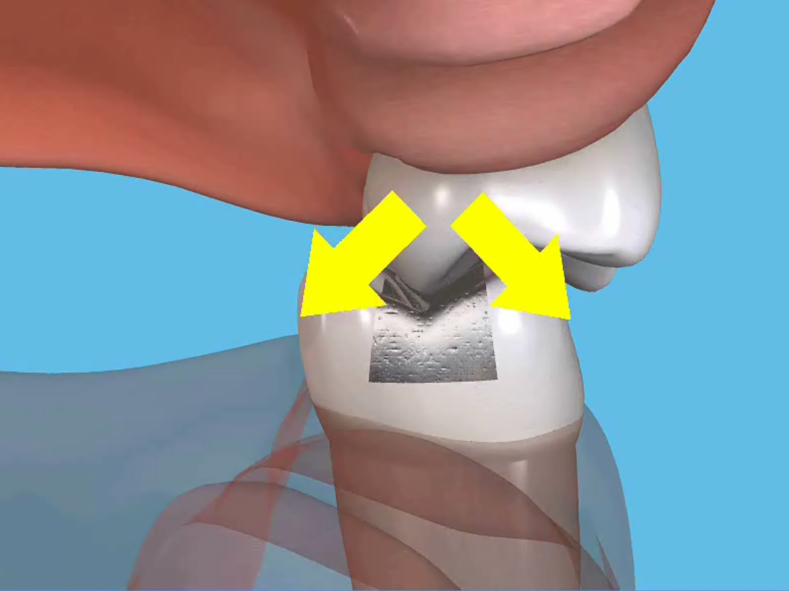
Q How will the dentist diagnose a cracked tooth?

A X-rays cannot show up a hairline crack. Diagnosis will depend on the information you give to the dentist. The filling will need to be removed and the tooth examined under magnification. Often a black line can be seen running through the tooth.

Q What can be done to treat the cracked tooth?

A The treatment to save the tooth depends on the extent of the crack. A crown would be the usual option but root canal treatment may be required before the tooth is crowned.

Q Are cracks likely to appear in my other teeth?

A Patients with one cracked tooth are likely to return with the same problem in a different tooth.

Q What can be done to prevent further cracked teeth?

A Your dentist might suggest making a night guard to protect your teeth from night-time clenching and grinding.

